Accommodate

Student User Guide

University of Denver

Disability Services Program (DSP)

Updated August 2021

Contents
Welcome to Accommodate 2
Accessing the Student Accommodate Home Page 2
Student Home Page Features 3
Accommodation Details Section 5
Initial Request for Accommodation (RFA) 5
Additional Accommodation Request(s) 5
Send Accommodation Letters 6
View Letters 6
Equipment 7
Notes 7
User Accessibility Mode 8
Schedule a Quiz, Test, or Final Exam in the DSP Testing Center 9
How to Schedule a Quiz, Test, or Final Exam in the DSP Testing Center 9
Fall 2021 Test and Final Exam Request Deadlines 14
Scheduling Expectations and Time Conflicts 14
How to Submit a Test Request 14
How to Cancel or Reschedule a Test Request 15

Welcome to Accommodate
The Disability Services Program (DSP) replaced our ClockWork (CW) system in June 2021 with the Accommodate system for students and faculty to use to interact with and track accommodation information for approved students.

Accessing the Student Accommodate Home Page
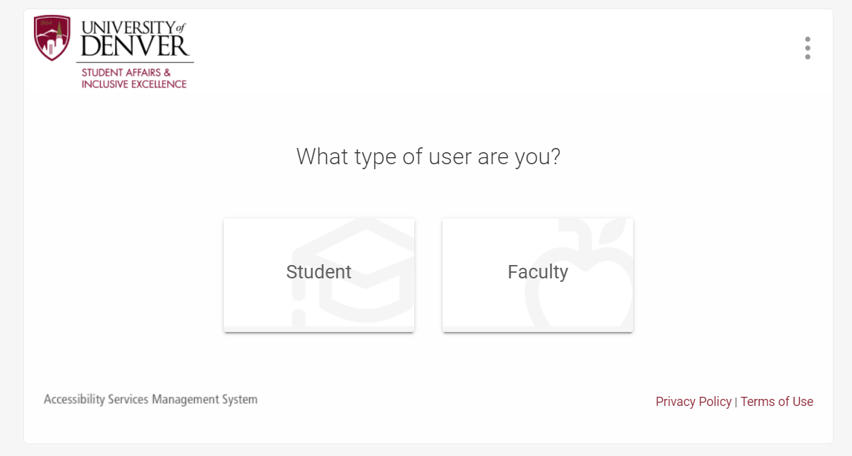To access your Accommodate Student Home Page, you will need to login in through the Accommodate Student Portal and follow the process below:

1. Open a web browser (Google Chrome, Firefox, Safari, and Edge).
2. Go to http://du-accommodate.symplicity.com/ (Please feel free to bookmark for future use).
3. Select Student.
4. Enter your University of Denver email and password.
5. Click the Login button.

Student Home Page Features
In this Section, learn more about the features included in the Student Accommodate Portal.
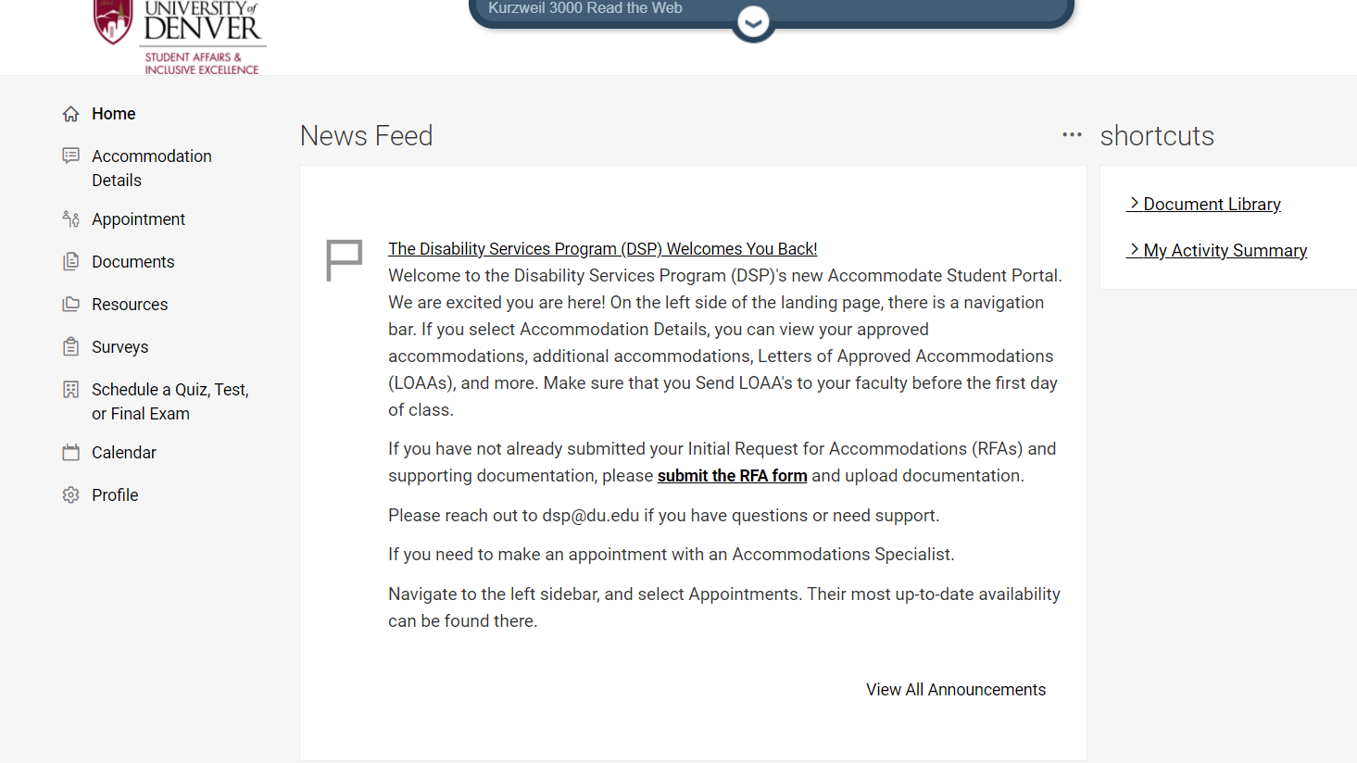
Once logged in through the Accommodate Student Portal, you will have access to your Home Page.
The Home Page includes a News Feed Section and a Navigation Menu on the left side.
The News Feed Section will include updates and announcements from DSP.
For example, “Don’t forget to send your Letters of Approved Accommodations (LOAAs)!”
On the left navigation menu, students can visit the following tab selections: Accommodation Details, Appointment, Documents, Resources, Surveys, Calendar, and Profile. If you are approved for testing accommodations, you can also visit the Schedule a Quiz, Test, or Final Exam tab.
- Accommodation Details: Includes Initial Request for Accommodation (RFA), Additional Accommodation Request, Send LOAAs to Faculty, View Letters, Equipment, and Notes. Additional information included on Page 5).
- Appointment: Students can schedule appointments with DSP Accommodation Specialists via the Appointment tab.
- Documents: Includes a Document Library where additional documentation (separate from requests) will be filed.
- Resources: Resources in the Resource Library are shared with students from DSP, including a copy of the DSP Student Handbook.
- Surveys: DSP may invite students to participate in surveys from time to time.
- Schedule a Quiz, Test, or Final Exam: Students with approved testing accommodations may schedule a quiz, test, or final exam in the DSP Testing Center.
- Calendar: An organized calendar is available to view your approved appointments with the DSP.
- Profile: Personal and password information can be viewed. Visit the Password/Preference tab to turn on Accessible Mode to improve accessibility and compatibility with screen reader software.

Accommodation Details Section
To review Accommodation Details, select the Accommodation Details Tab. The Accommodation Details section includes your Initial Request for Accommodations (RFA), Additional Accommodation Requests, Sending of LOAAs to Faculty, previous sent Letters, Equipment and Notes. 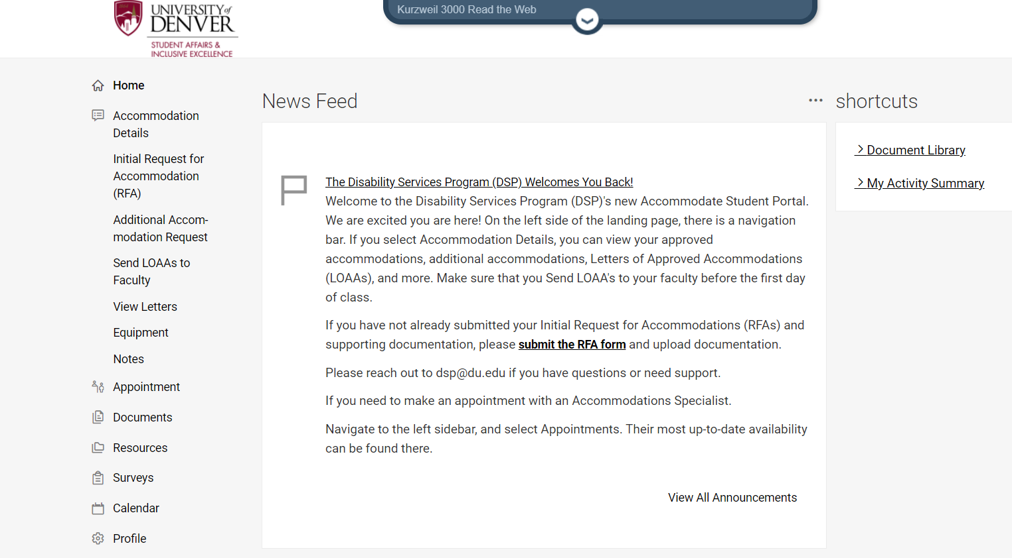

Initial Request for Accommodation (RFA)
To submit an Initial Request for Accommodation (RFA), students need to complete the Initial Request for Accommodation (RFA) form which includes uploading supporting documentation. The initial Request for Accommodation (RFA) tab will reflect the first time that you requested accommodations through DSP.
Please note: The supporting documentation that you provide needs to meet the criteria included in the DSP’s Documentation Guidelines.

Additional Accommodation Request(s)
To submit Additional Accommodation Request(s), students need to add a new request form through the Additional Accommodation Request tab.
1. Select Add New.
2. Complete the Additional Accommodations Request form.
3. Attach additional documentation if applicable.

Send Accommodation Letters
To send current Letters of Approved Accommodations (LOAAs) to your instructors, students need to navigate to the Send LOAAs to Faculty tab under Accommodation Details. This letter will notify your instructors of your approved accommodations to ensure they are implemented.
Students can send their LOAAs by following the process below:
1. Log into Student Accommodate Portal.
2. Select Send LOAAs to Faculty tab.
3. Select Add New (No need to search through long list of terms).
4. At the top, you can note your approved academic/testing accommodations.
5. Select the current Term
6. Select Send By Course
You will need to determine which academic/testing accommodations will be sent to each of your instructors. Your approved accommodations will appear as a list, you will need to go through accommodation by accommodation and select which instructors will be notified of the accommodation(s).

View Letters
Includes all letters that have been sent to you from DSP in Accommodate, including Eligibility Notifications, Notification of Additional Accommodations, as well as LOAAs sent to faculty. Your letters can be revisited whenever is needed. At times, DSP may request student signature on letters, such as Eligibility Notifications, sent LOAAs, or Audio Recording Memorandums.

Equipment
This tab is currently a work in progress, DSP will send notice to all students when this tab is ready to be accessed.

Notes
The Notes tab includes referred resources or important information discussed with DSP, that can be specific to you or a general resource.

User Accessibility Mode
The Accommodate Software has an Accessibility Mode that can be turned on by the user.
Accessibility Mode is only recommended for users of assistive technologies. Functionality and content are equivalent in Accessibility Mode, but some interface elements will be formatted differently for optimal compatibility.
Prior to logging in, users can turn on Accessibility Mode by selecting the three (3) vertical dots in the top right of the login screen. Users can also turn on Accessibility Mode by selecting Profile, Password/Preferences.
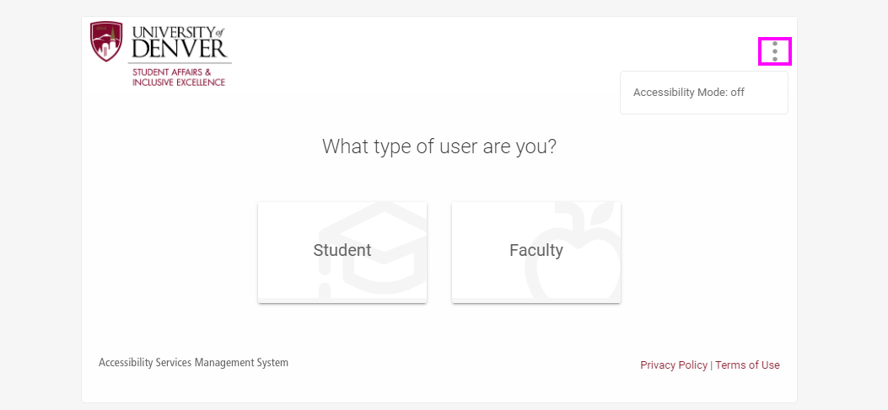
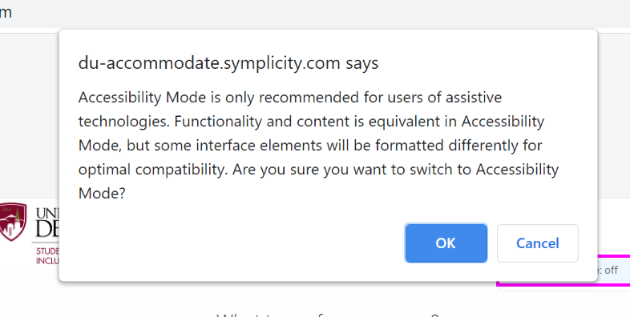

Schedule a Quiz, Test, or Final Exam in the
DSP Testing Center
Students who have approved testing accommodations through the DSP and take timed assessments (quizzes, midterms, tests, final exams) in the DSP Testing Center are responsible for submitting test requests prior to the sign-up deadlines. Visit the DSP Testing Center web page to learn more about DSP Testing Center location, hours, policies and procedures.
Students are required to Send LOAAs to Faculty prior to submitting requests to take quizzes, tests, or final exams in the DSP Testing Center. When a student has successfully sent their LOAAs to faculty, the Schedule a Quiz, Test, or Final Exam tab appears in the left navigation menu.

How to Schedule a Quiz, Test, or Final Exam in the DSP Testing Center
- Login to Accommodate.
- Send LOAAs to Faculty at the beginning of each term.
- Select Schedule a Quiz, Test, or Final Exam
.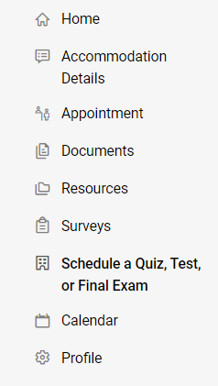

- Review important testing information included in the blue information box. This information is included on Page 14 and Page 15. 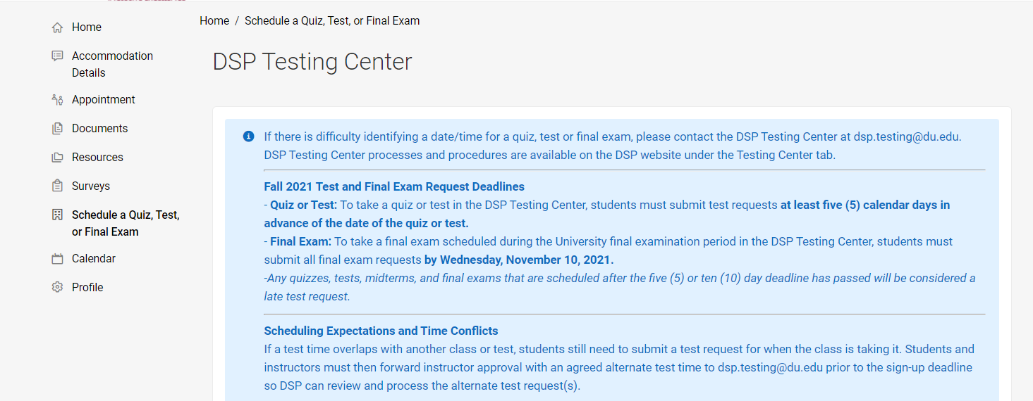

- Scroll down and click New Quiz, Test, or Final Exam Request.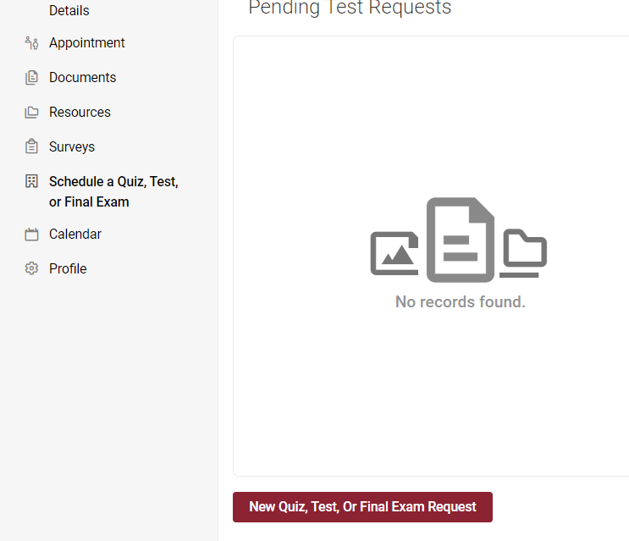

- Choose the Course for the test you are requesting to take in the DSP Testing Center.
  - To submit a request for a final exam that is scheduled during the University Final Examination period, select the course that has -E in the course name.
- Answer Yes or No to the question, “Is this test for an online or evening course?”
- Select Testing Center for the Building.
- Specific Accommodation Required – Deselect any accommodations that are listed that you do NOT want to use during this exam.
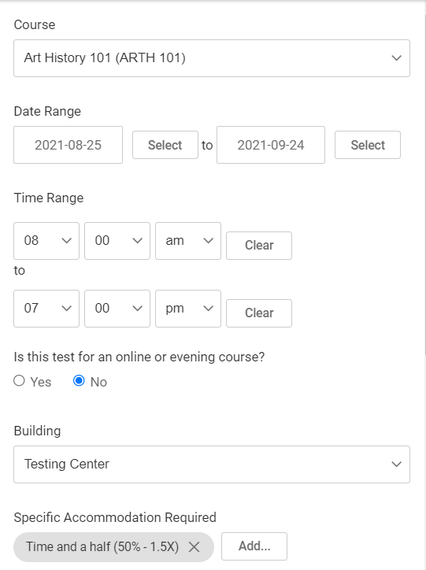

- Select Check Availability.
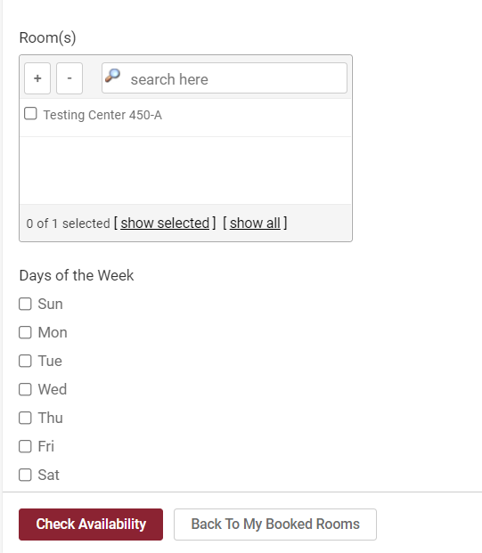

- In the right column, select the day and start time you would like to request to take the test.
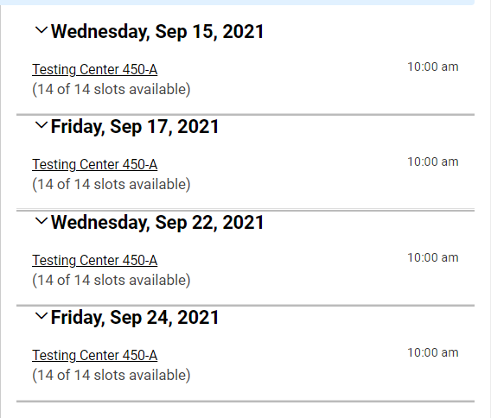
Note: Accommodate is tied to your course schedule. If you need to request an alternate start time because of a time conflict with another class or exam, you will still need to request the test for the same time the class takes it, then you or your instructor will email approval for an alternate test time to dsp.testing@du.edu.
- In the Confirm Exam Booking pop-up window, review information to make sure it is correct. Include any notes or additional information that would be helpful for DSP (e.g. pop quiz, class gets 10 minutes). Click Submit Request.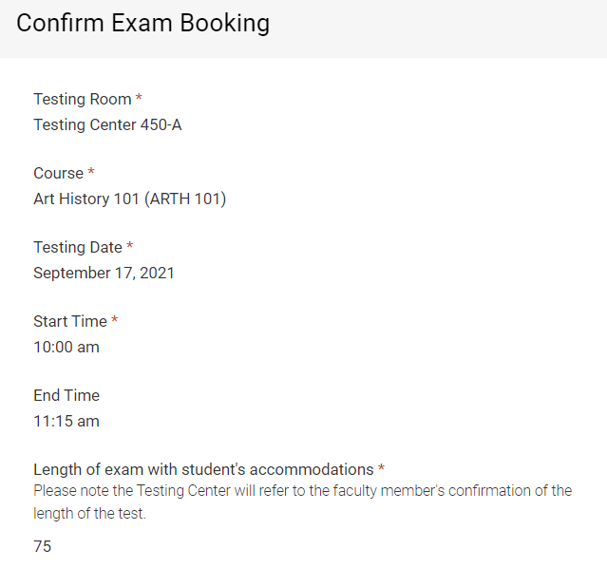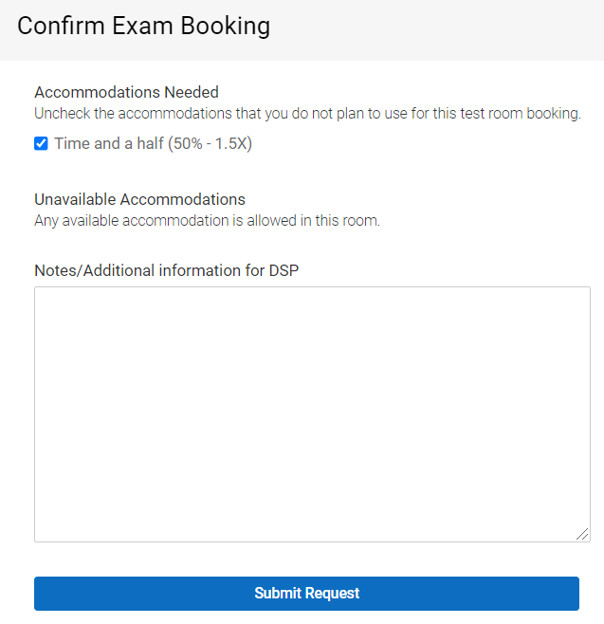

- If request has successfully been submitted, it will appear under Pending Test Requests. The student will also receive an automated email confirming the test request was successfully submitted.
- Approved test requests will appear under the Approved Test Request section. The student will also receive an email from DSP confirming the test request was approved. An email will go out to a student when DSP is unable to approve a test request.
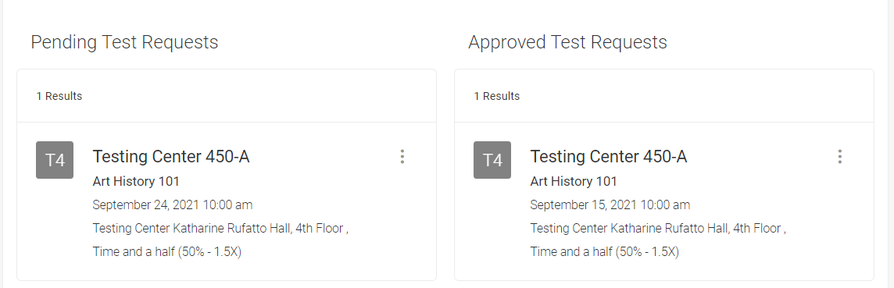

If there is difficulty identifying a date/time for a quiz, test or final exam, please contact the DSP Testing Center at dsp.testing@du.edu.DSP Testing Center processes and procedures are available on the DSP website under the Testing Center tab.

Fall 2021 Test and Final Exam Request Deadlines
- Quiz or Test: To take a quiz or test in the DSP Testing Center, students must submit test requests at least five (5) calendar days in advance of the date of the quiz or test.
- Final Exam: To take a final exam scheduled during the University final examination period in the DSP Testing Center, students must submit all final exam requests by Wednesday, November 10, 2021.
-Any quizzes, tests, midterms, and final exams that are scheduled after the five (5) or ten (10) day deadline has passed will be considered a late test request.
Scheduling Expectations and Time Conflicts
If a test time overlaps with another class or test, students still need to submit a test request for when the class is taking it. Students and instructors must then forward instructor approval with an agreed alternate test time to dsp.testing@du.edu prior to the sign-up deadline so DSP can review and process the alternate test request(s).

How to Submit a Test Request
- Scroll down to and select New Quiz, Test, or Final Exam Request.
- Select the following: Course**, Yes or No for the online/evening course question, Building (Testing Center), Specific Accommodation Required, then Check Availability.
- In the right column, select the day and time for your test request.
- Review information in the Confirm Exam Booking pop-up window then Submit Request. When a test request has successfully been submitted, it will appear under the Pending Test Requests section.
- To submit a request for a final exam that is scheduled during the University Final Examination period (November 20 – 23, 2021), select the course that has -E in the course name.

How to Cancel or Reschedule a Test Request
- To cancel a pending or approved test request, click on the three dots in the test request and select Cancel.
- To reschedule a pending or approved test request, cancel the request then submit a new quiz, test, or final exam request.

